**Update 25 Feb 2021**

* Hannah review updated model provided by Tim on 15th February. A few issues identified - see text below in yellow.

**Calculations/model**

1. *Egg numbers*
   * Error in the calculation for egg numbers. See screen recording [here](https://globalfoodpartners.sharepoint.com/:v:/s/mtrlrcs/EUQHPC7L6ClDg5usRxx99K0BfTRlz-k6BB7WFaxMSSGUdA?e=OcEudY) – 1 hen, laying at 100% with no mortality and no breakages, should produce 30.5 eggs per month, not 3050 eggs. Decimal place off by 2 places. I think this is due to the ‘average laying %’ being included in the calculation as the actual % (e.g. 80 or 90), as opposed to a decimal (e.g. 0.8 or 0.9). Sorry, I may not have explained this clearly in the spreadsheet sent back in December.
     + Fixed :)
2. *Cost of pullets* – *add this cost to year 1, period 1*
   * Currently, pullet costs (cost per pullet x flock size) is added to the calculation in the downtime period (i.e. the last is_transition month of each cycle starting with the second period/cycle). This is correct. However, this same figure (cost per pullet x flock size) should also be added to month/period 1 of year 1 – otherwise we are omitting the cost of pullets from the farmers first period/cycle. See screen recording [here](https://globalfoodpartners.sharepoint.com/:v:/s/mtrlrcs/Ef8Zmn1EWm5Fu_B3oT51G5UBpxF06CSVwo9SgKWfk7LBwQ?e=xPkXYk). Can you please add this cost to appear in month 1, year 1 (in addition to how it is currently set up to occur in the is transition period)?
     + Cost of pullets has been added to every month in year 1, but should only be added to month 1 of year 1. See screen shots below:

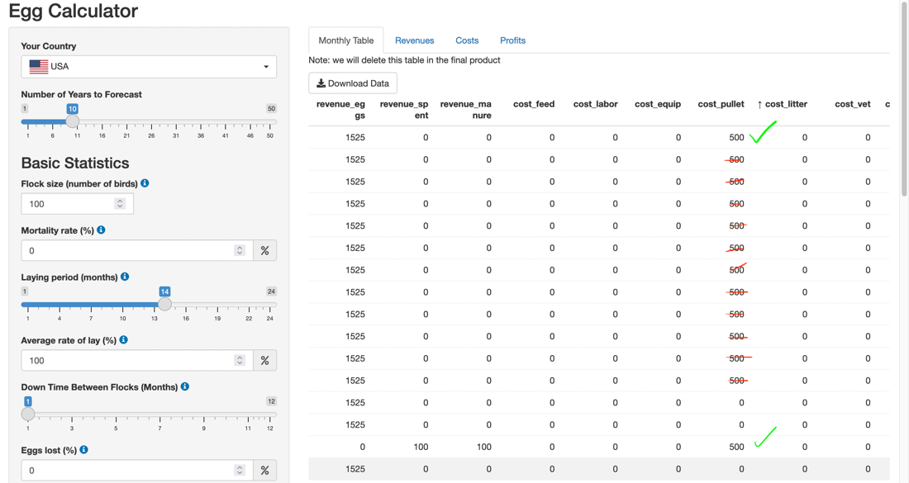

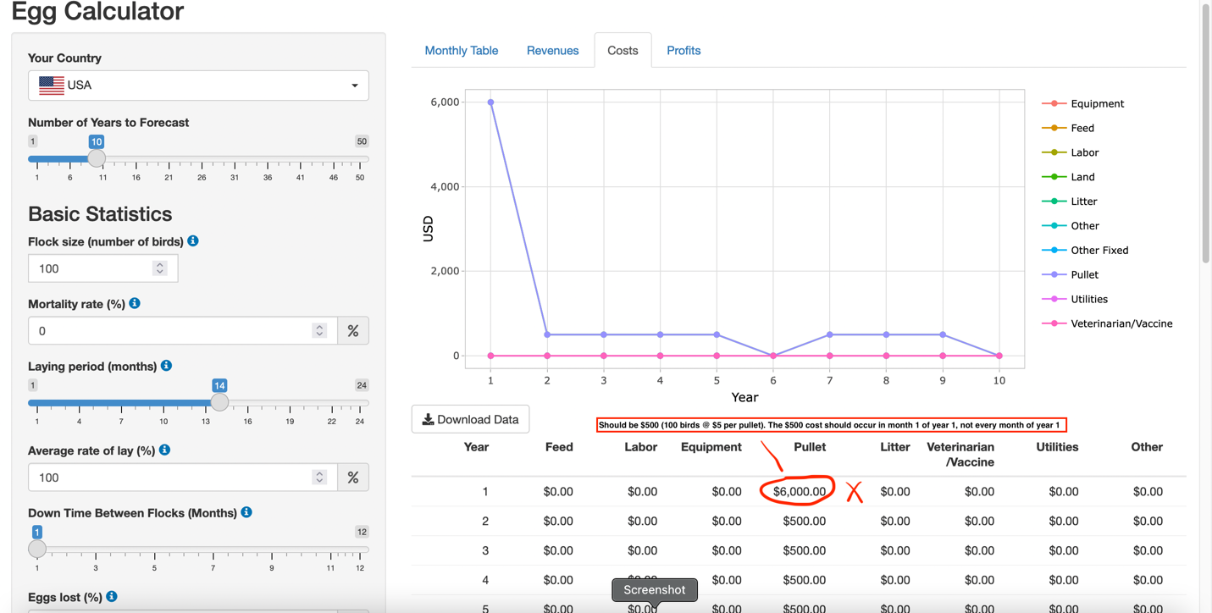

1. *Value limits*
   * Laying period (months) - current limit on the sliding bar is 20 months. Please increase to 24 months
     + Fixed :)
   * Please remove value limits on all cost boxes (e.g. If I try to enter a value greater than 5000 in the feed cost box, it turns red). The values in each box will vary greatly due to; difference in currency value ($1 USD equates to a little over 14,000 Indonesian Rp!); difference in costs between farms and depending on size of flock. I think it is best to remove all limits and allow farmers to enter any value in the costs section.
     + Fixed :)
   * I also noticed if you include a comma an any of the values (e.g. input 1,000 rather than 1000), that factor is not included in the calculation. But the box does not turn red to let you know there is an error. See screen recording [here](https://globalfoodpartners.sharepoint.com/:v:/s/mtrlrcs/EUVrkzUsBXpPp5uFPRSTvLoB14rXvJb9nujtFq5zsyVwlw?e=bFcocZ) Is there a way to either notify people about the error if they use a comma OR restrict the setting so only numbers can be entered in these boxes, not text or symbols etc.
     + Any thoughts on this? Just wanting to avoid the situation where someone enters a value that includes a comma and they think it has been included in the calculation, but it hasn’t.

**Graphs/Tables**

* Revenues tab
  + Thanks for adding egg numbers to the table and graph for this tab!
  + Y axis
    - Can the Y-Axis for the ‘Eggs’ graph (red line) at the top be labelled ‘Number of eggs’?
    - [Currency] label is only relevant for the revenues graph underneath
      * Fixed :)
  + Revenues graph
    - Can we split the revenues graph into two: (i) *Revenue from eggs* and (ii) *Revenue from spent hens and manure*. Reason = due to the difference in revenue for the 3 sources. Eggs will always be the primary source of income, by a lot! If we keep all 3 sources on the same graph, due to the scaling on the Y-axis, the revenue from spent hens and manure will generally appear as a flat line on the ‘0’ mark.
  + I’ve sketched out what I mean in the above 2 points, see image below:

* + - ‘Revenue from egg’s is missing. I can only see the chart for egg numbers and revenue from manure/hens (as per screen shot below). Please add ‘Revenue from eggs’ back into the display.
    - Also, Y-axis text (Number of eggs and currency) overlap the Y-axis numbers - not a big deal but would be nice if they could be spaced out a bit more so the text and numbers don’t overlap.

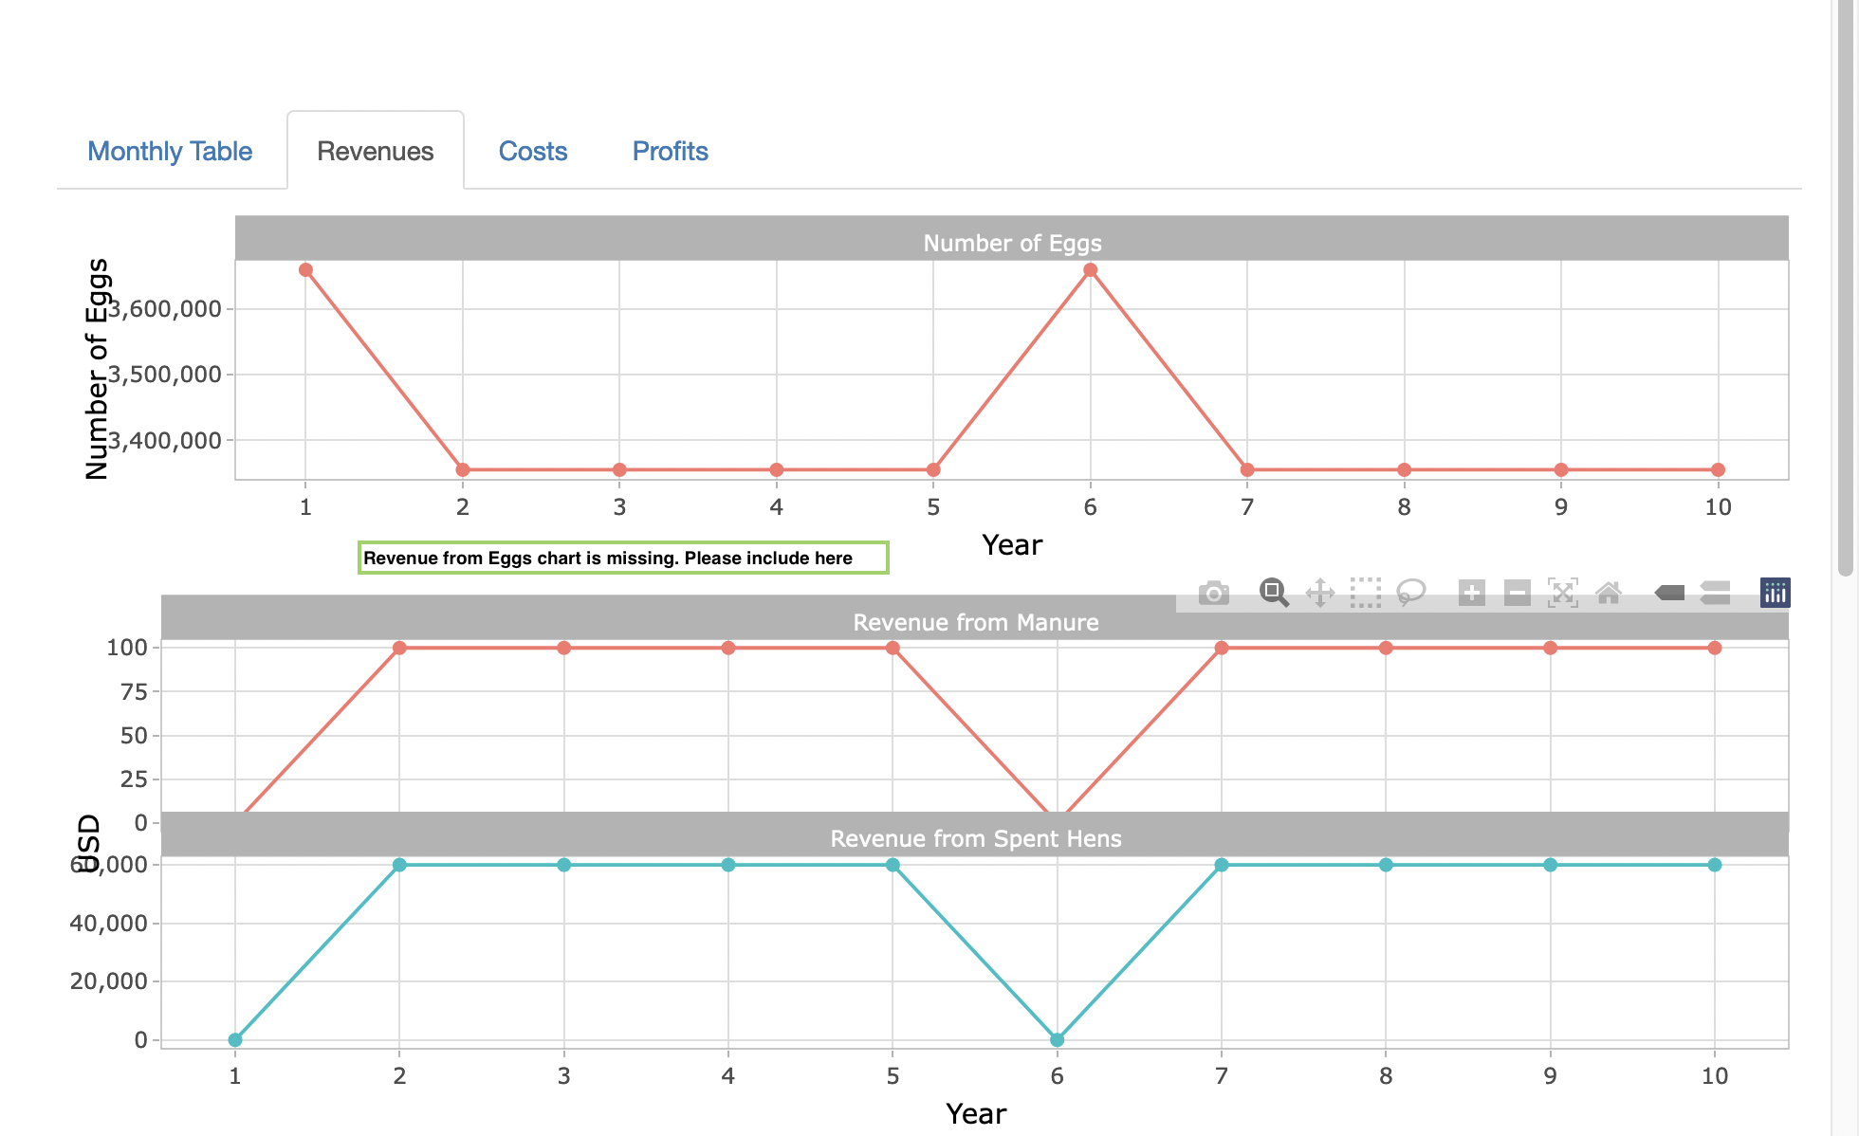

New issue identified 25 February with the calculations for costs:

* I’m not exactly sure what is going on, but there appears to be a bug or error in the cost calculations for land costs, other fixed costs and total costs. Or it could be that the headings in the cost chart and table are mislabelled.
* Screen recording [here](https://globalfoodpartners.sharepoint.com/:v:/s/mtrlrcs/ET1mV87159VFvdE_KN6LaAgBiFS05z_Z_ezuTAcKpX-UbQ?email=timhister%40protonmail.com&e=b6wc8R) hopefully explains it:

1. Land cost calculation (in the costs table and graph) appears to show that for total costs
2. If you enter data into the ‘Other fixed costs (yearly)’ box, it appears under the total cost heading
3. If you enter data into the ‘Land (yearly)’ box, if appears under the ‘Other fixed’ heading